Newsletter June 2015

Volume 6

[](http://www.google.com/url?sa=i&rct=j&q=&esrc=s&source=images&cd=&cad=rja&uact=8&docid=a88iZ7oifaOPKM&tbnid=dbkuZpIKSciBHM:&ved=0CAUQjRw&url=http://www.bubblews.com/news/3099447-did-you-know&ei=LsWMU4OVIoOMqAbohIG4DQ&bvm=bv.67720277,d.b2k&psig=AFQjCNECJyZnfKRCg59x5im_0pz3PmZpjg&ust=1401820656968446)

**Our office will be closed Friday July 3rd, 2015 in observance of the 4th of July holiday.**

**Meet the MUA Staff**

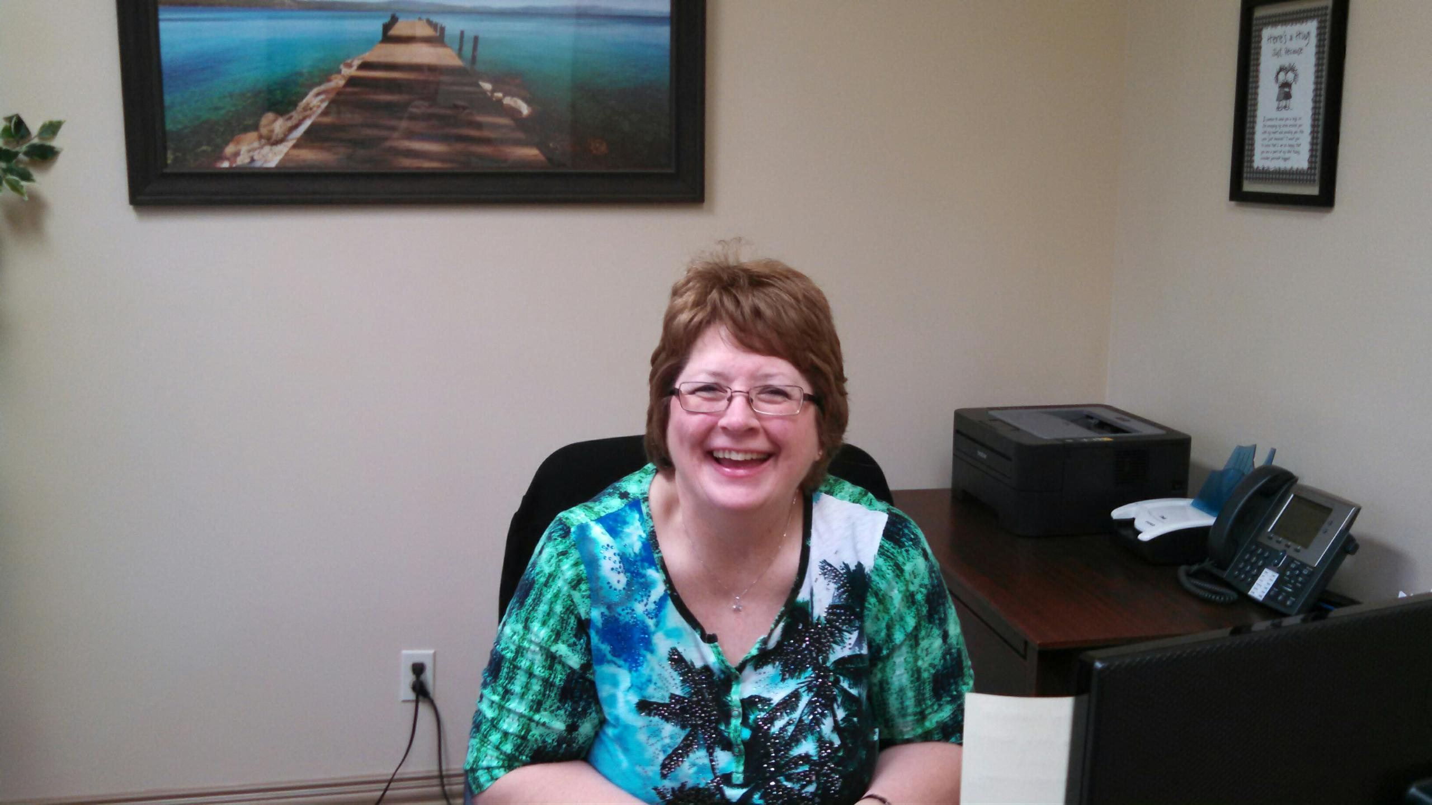

**Paula Parsley**

**Paula has been with MUA since**

**December 12th, 2011 as an**

**Underwriting Assistant. She now handles our Accounts Receivables.**

**Paula has been married for 18 years.**

**Her hobbies include bowling, baking, fishing and spending time with her family and friends.**

**Paula was the 2013 Women’s National Doubles Champion.<!-- Size: 140 px -- >  
<img src='www.clker.com/cliparts/1/7/5/6/13523340551621864223string-around-finger-never-dont-forget-th.png'>**

**OCEAN MARINE**

Marine GL incl Ship Repairers, Terminal Operators, Marina Operators, Wharfingers, Stevedores Legal Liability

Boat Dealer Inventory

Excess Marine Liability

Charterers Legal Liability

Hull / Protection & Indemnity

Marine Liabilities

Hull Builders Risk

Motor Truck Cargo Legal Liability

(when written in association with Ocean Cargo)

Ocean Marine related Inland Marine

**INLAND MARINE**

Contractor’s Equipment

Builder’s Risk/Installation

EDP and mobile medical equipment

Motor Truck Cargo (local & some intermediate carriers)

Bailee’s Legal/Warehouseman’s Legal

Miscellaneous Property

Bridges

Rigger’s Legal Liability

**DRY PROPERTY TO SUPPORT MARINE PACKAGES**

Storage buildings / Club houses / Restaurants / Repair Facilities / Manufacturing / Showrooms / Offices

Marine Underwriters of America, 2040 North Loop 336 West, Suite 225, Conroe, TX 77304

[www.marineuw.com](http://www.marineuw.com) 936-230-5537

# Products Offered

### Inside This Issue

Did you Know? 1

Products Offered 1

Recently Written Accounts 2

MUA Contact Information 3

General Information 3

MUA Communique’

**MGL/MOLL:**

**\*Marina operator incl schedule of CE and**

**miscellaneous tools in FL $8,200**

**\*Marina operator in LA $18,357**

**\*Marina operator incl piers & wharves coverage in MO $5,100**

**\*Marina operator incl piers & wharves coverage in FL $16,787**

**\*Marina operator incl piers & wharves coverage in NY $5,500**

**\*Marina operator incl P&I coverage for schedule of**

**workboats & schedule of miscellaneous**

**tools in AL $6,622**

**\*Marina operator incl P&I coverage for schedule of**

**workboats in LA $24,040**

**\*Marina operator incl Hull/P&I coverage for schedule of**

**workboats & piers & wharves coverage in KY $45,032**

**\*Boat Dealer incl coverage for owned inventory in NY $9,775**

**\*Boat Dealer incl coverage for owned inventory in TX $5,040**

**\*Boat Dealer incl coverage for owned inventory &**

**Piers & wharves coverage in TX $117,185**

**Hull/P&I:**

**\*Schedule of airboats in LA $25,000**

**\*Schedule of workboats in LA $6,480**

**\*Schedule of airboats in LA $11,600**

**Real Property coverage for marina operator in MO $4,043**

**Real Property coverage for marina operator in FL $3,969**

**Excess Liability:**

**\*Boat Dealer in TX ($1m xs $1m) $5,500**

**\*Marina Operator in FL ($5m xs $1m) $8,000**

# Recently Written Accounts

Page 2

MUA Communique’

Main Office: 936-230-5537

Office Fax: 936-230-5538

Mike Hartley: President

[mike@marineuw.com](mailto:mike@marineuw.com)

Direct: 936-756-9983

Cell: 713-291-2135

Michele Kirkland: Office Manager/Sr Underwriter

[michele@marineuw.com](mailto:michele@marineuw.com)

Direct: 936-756-9986

Cell: 832-573-2617

Kevin Belk: Underwriter

[kevin@marineuw.com](mailto:kevin@marineuw.com)

Direct: 936-756-9985

Cell: 704-604-6539

Kim Hartley: Accounts Payable

[kim@marineuw.com](mailto:kim@marineuw.com)

Direct: 936-756-9984

Cell: 713-269-5893

Hailey Miears: Underwriting Assistant /

Policy Issuance [hailey@marineuw.com](mailto:hailey@marineuw.com)

Direct: 936-756-9988

Paula Parsley: Account Receivable

[paula@marineuw.com](mailto:paula@marineuw.com)

Direct: 936-756-9987

Holly Fayle: Underwriting Assistant /

Policy Issuance

[holly@marineuw.com](mailto:holly@marineuw.com)

Direct: 936-756-9989

**In-Box for all new & renewal submissions:**

[submissions@marineuw.com](mailto:submissions@marineuw.com)

**In-Box for all claim reporting:**

[claims@marineuw.com](mailto:claims@marineuw.com)

**In-Box for all loss run requests, “subject to” items remittance, Loss control recommendation(s) remittance & general requests:** [MUA@marineuw.com](mailto:MUA@marineuw.com)

**\*All MUA applications, including our Renewal Questionnaire are available on our website @**

<http://www.marineuw.com/Applications.php>

**\*\*MUA forms are available on our website as well.**

**You will be required to have a secure ID and Password. Please contact your underwriter to obtain your secure ID and Password.**

# General Information

# MUA Contact Information Everyone

MUA Communique’

Page 3