Newsletter March 2015

Volume 3

[](http://www.google.com/url?sa=i&rct=j&q=&esrc=s&source=images&cd=&cad=rja&uact=8&docid=a88iZ7oifaOPKM&tbnid=dbkuZpIKSciBHM:&ved=0CAUQjRw&url=http://www.bubblews.com/news/3099447-did-you-know&ei=LsWMU4OVIoOMqAbohIG4DQ&bvm=bv.67720277,d.b2k&psig=AFQjCNECJyZnfKRCg59x5im_0pz3PmZpjg&ust=1401820656968446)

**Our office will be closed Friday April 3rd in observance of Good Friday.**

**Meet the MUA Staff**

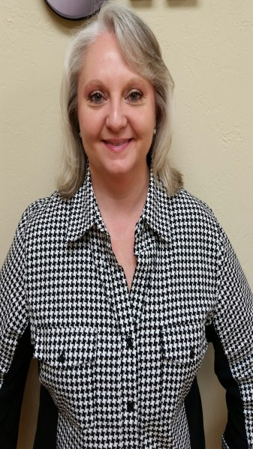

**Holly Fayle**

**Holly has been with MUA since**

**February 17th, 2015 as one of our much appreciated Underwriting Assistants.**

**Holly has been married for 21 years and has 3 children and 1 grandchild. Her hobbies include cooking, reading, fishing and spending time with her family. Holly also has her cosmetology license and enjoys making clients beautiful in her free time.<!-- Size: 140 px -- >  
<img src='www.clker.com/cliparts/1/7/5/6/13523340551621864223string-around-finger-never-dont-forget-th.png'>**

**OCEAN MARINE**

Marine GL incl Ship Repairers, Terminal Operators, Marina Operators, Wharfingers, Stevedores Legal Liability

Boat Dealer Inventory

Excess Marine Liability

Charterers Legal Liability

Hull / Protection & Indemnity

Marine Liabilities

Hull Builders Risk

Motor Truck Cargo Legal Liability

(when written in association with Ocean Cargo)

Ocean Marine related Inland Marine

**INLAND MARINE**

Contractor’s Equipment

Builder’s Risk/Installation

EDP and mobile medical equipment

Motor Truck Cargo (local & some intermediate carriers)

Bailee’s Legal/Warehouseman’s Legal

Miscellaneous Property

Bridges

Rigger’s Legal Liability

**DRY PROPERTY TO SUPPORT MARINE PACKAGES**

Storage buildings / Club houses / Restaurants / Repair Facilities / Manufacturing / Showrooms / Offices

Marine Underwriters of America, 2040 North Loop 336 West, Suite 225, Conroe, TX 77304

[www.marineuw.com](http://www.marineuw.com) 936-230-5537

# Products Offered

### Inside This Issue

Did you Know? 1

Products Offered 1

Recently Written Accounts 2

MUA Contact Information 3

General Information 3

MUA Communique’

**MGL/SRLL:**

**\*Boat repair operation in FL $3,155**

**\*Boat detailer operation in SC $4,011**

**\*Underwater boat cleaning operation in CA $2,500**

**MGL/MOLL:**

**\*COA Dock owner in FL $3,750**

**\*Marina operator in FL $5,950 *Marina operator in FL $3,075**

**\*Boat Dealer incl coverage for their owned inventory &**

**schedule of miscellaneous tools in TX $15,200**

**\*Marina operator incl Hull/P&I coverage for their owned**

**Boats and schedule of CE in FL $32,004**

**MGL/Contractor LL:**

**\*Seawall repair operation in LA $2,500**

**MGL/Wharfingers LL:**

**\*Dock owner including coverage for their dock in NY $90,350**

**MOLL:**

**\*Terminal owners/operator in LA $10,000**

**Inland Marine:**

**\*Schedule of Contractors Equipment for steel**

**construction company in TX $4,634**

**Real Property coverage for marina operator in FL $1,596**

**Excess Liability:**

**\*Marina Operator in TX ($1m xs $1m) $10,520**

**\*Marina Operator in AL ($5m xs $1m) $17,450**

# Recently Written Accounts

Page 2

MUA Communique’

**In-Box for all new & renewal submissions:**

[submissions@marineuw.com](mailto:submissions@marineuw.com)

**In-Box for all claim reporting:**

[claims@marineuw.com](mailto:claims@marineuw.com)

**In-Box for all loss run requests, “subject to” items remittance, Loss control recommendation(s) remittance & general requests:** [MUA@marineuw.com](mailto:MUA@marineuw.com)

**\*All MUA applications, including our Renewal Questionnaire are available on our website @**

<http://www.marineuw.com/Applications.php>

**\*\*MUA forms are available on our website as well.**

**You will be required to have a secure ID and Password. Please contact your underwriter to obtain your secure ID and Password.**

# General Information

Main Office: 936-230-5537

Office Fax: 936-230-5538

Mike Hartley: President

[mike@marineuw.com](mailto:mike@marineuw.com)

Direct: 936-756-9983

Cell: 713-291-2135

Michele Kirkland: Office Manager/Sr Underwriter

[michele@marineuw.com](mailto:michele@marineuw.com)

Direct: 936-756-9986

Cell: 832-573-2617

Kevin Belk: Underwriter

[kevin@marineuw.com](mailto:kevin@marineuw.com)

Direct: 936-756-9985

Cell: 704-604-6539

Kim Hartley: Accounting

[kim@marineuw.com](mailto:kim@marineuw.com)

Direct: 936-756-9984

Cell: 713-269-5893

Hailey Miears: Underwriting Assistant [hailey@marineuw.com](mailto:hailey@marineuw.com)

Direct: 936-756-9988

Paula Parsley: Underwriting Assistant

[paula@marineuw.com](mailto:paula@marineuw.com)

Direct: 936-756-9987

Holly Fayle: Underwriting Assistant

[holly@marineuw.com](mailto:holly@marineuw.com)

Direct: 936-756-9989

# MUA Contact Information Everyone

MUA Communique’

Page 3